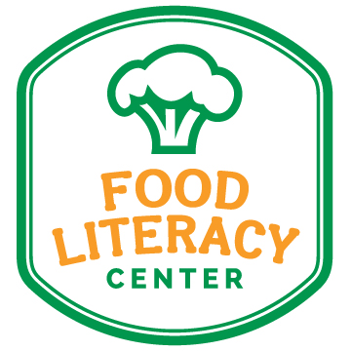
Food Literacy Summer Program Interns Needed!

Do you think food should be fun? Do you believe education is empowerment? Do want to help change kids’ eating habits in a way that could affect them for a lifetime? If so, you should think about joining our team at Food Literacy Center! We believe that food education should be fun, approachable and practical. We want to empower kids to explore more foods and make smart choices on their own. Our mission is to inspire change today for a healthy, sustainable tomorrow through enduring community food education.

What’s required to become one of our amazing unpaid Summer Program Interns:
- Experience with or desire to work with kids (pre-K-5th graders)
- Basic knowledge of nutrition
- Able to commit for summer session, June 1-August 31 (10-20 hours/week)
- Have your own transportation
- Comfortable public speaking
- Strong communication skills
- Ability to work as a team with adult leaders
- Ability to work independently as leader of a small group (consisting of children and their parents)
- Ability to multitask and take initiative when necessary
- Capable of maintaining a joyful personality, even in times of “chaos”

Your role:
You will be assisting one or more Food Literacy Advocates (our trained adult volunteers) at various public libraries in Sacramento County. The libraries will be advertising our free Food Literacy Programs to the public, encouraging parents to bring their children of any age to come join the fun. We will be teaching a variety of lessons, many of which involve making a recipe. Recipe lessons need a lot of preparation chopping and measuring ingredients. Many of the lessons require breaking into small groups; in these cases you will be proceeding with the lesson on your own and answering any questions that arise. You will also be shadowing the Lead Advocate. The more hands and positive attitudes we have, the more kids we will be able to reach!

Additional summer activities include public outreach during fairs, farmers markets and events, and assisting with planning activities for Food Literacy Month events in September.

If you believe in our mission to inspire kids to eat their vegetables, then send us your resume and cover letter by May 1. In your cover letter, let us know what an awesome person like you can bring to the program. Please send your resume and cover letter to elaine@foodliteracycenter.org, subject: Summer Program Intern Application. If we like what we see, then we will schedule a phone interview with you and make our final decisions by May 15.

Please note: this is an unpaid internship.

